

In memory of

**Kathy Chester**

# This is the twenty-seventh annual seminar series sponsored through the Kathy Chester Memorial Endowment Fund. As a Riverside Speech Pathologist, Kathy was a strong advocate for continuing education and these seminars are a tribute to Kathy and her contribution to our field.

# The Twenty-Seventh Annual

Kathy Chester

# Memorial Seminar Series

***“Practical Tips for Person-Centered and Culturally Responsive Care”***

Chung Hwa L. Brewer MA, CCC-SLP

Tuesday, May 20, 2025

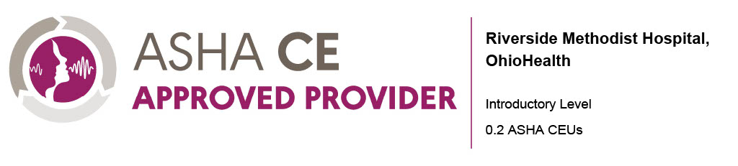

## Seminar Description

This course will allow attendees to improve their ability to provide person-centered and culturally responsive care.  Tips for integration into daily work life will be reviewed including interviewing strategies, active listening concepts, self-awareness practice, mindfulness, and self-advocacy.

## Speaker

## Chung Hwa L. Brewer, MA, CCC-SLP, is an SLP, author of The Adult Speech Therapy Workbook, and instructor at Western Washington University, where she teaches Social, Political, and Cultural Aspects of CSD. She currently works in home health, and has previously worked in hospitals, skilled nursing facilities, and telehealth. She is the co-founder of adultspeechtherapy.co, with the mission to increase your ability to assess, document, and treat with more confidence and ease. She lives in Washington State with her family.

**Financial Disclosures:**

* Receives a speaking fee from OhioHealth

**Non-Financial Disclosures**:

* Has no relevant non-financial relationships to report

## Learner Objectives

After completion of this activity, participants will be able to:

1. Define person-centered and culturally responsive care
2. Describe how SLP's can practice person-centered and culturally responsive care

## Seminar Schedule

12:00-12:10 Introduction & Quick definitions

12:10-12:20 Why does this topic matter? Determinants of health, population changes, etc.

12:20-12:30 Intro to Person-Centered Care

12:30-12:45 Intro to Culturally Responsive Care

12:45-1:45 How to actually do this on the job: interviewing tips, active listening, self-awareness practice, self-advocacy, mindfulness, etc.

1:45-2:00 Conclusion: Questions, etc.

## Location

VIRTUAL ONLY

**For more information or questions, contact:**

Rehab Education

Email: [RehabEducation@ohiohealth.com](mailto:RehabEducation@ohiohealth.com)

## Registration

Register online at:

<https://ohiohealth.cloud-cme.com/Person-Centered-Culturally-Responsive>

**$50.00**